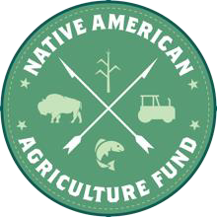

Options to Reduce PDF File Size

The 2025 Request for Applications (RFA) requires applicants to complete an online application. The application has different types of questions, including space to upload files directly to the application packet. Examples of files that require uploading include proof of eligibility documents, request budgets and cover letters. Most upload areas in the application are restricted to PDF files because they offer universal compatibility and reliability. However, sometimes converting a file to PDF increases the size of the file, making it too large to upload. If you run into this issue, follow the steps below to reduce PDF file size so you can proceed with the application.

# Option 1: Adobe Acrobat Pro DC

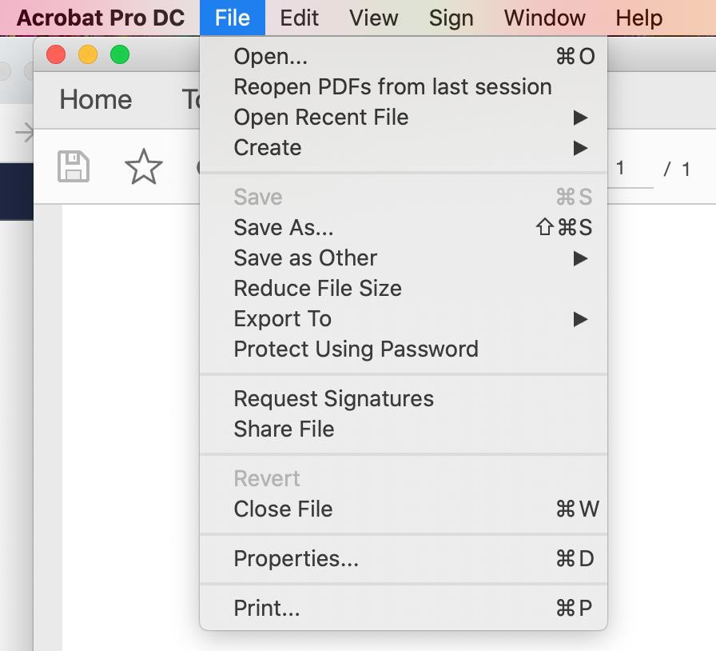

One simple way to reduce file size is to open the file in Adobe Acrobat Pro DC and use it’s “reduce file size” feature. Find more information here: https://helpx.adobe.com/acrobat/using/optimizing-pdfs-acrobat-pro.html

# Option 2: Foundant’s Suggestion

Another way to reduce file size is to follow the link given by Foundant support team. Find more information here: <https://smallpdf.com/compress-pdf>

**Need Help?**

If you try these steps and still aren’t able to upload your PDF, please reach out for assistance. Email: [grants@nativeamericanagriculturefund.org](mailto:grants@nativeamericanagriculturefund.org)

Phone: 479-368-8202